Planning Workstream
Executive Summary
2026 Bay Area UASI AI and Cybersecurity Project
The Planning Workstream established a common regional approach for assessing and improving cybersecurity and artificial intelligence governance maturity across participating Bay Area jurisdictions. The effort was designed as a self-assessment and improvement process, not a compliance audit or inspection, and produced a repeatable model for baseline assessment, gap identification, action planning, and reassessment.

Project by the Numbers
Measure | Project Result
Bay Area UASI jurisdictions engaged | 14
Jurisdictions completing and returning self-assessments | 11
Assessment participation rate | 79%
Jurisdictions continuing into tailored improvement planning | 10
Assessment-only jurisdictions | 1
Jurisdictions not completing the assessment during the project period | 3
Tailored 90-Day Action Plans produced | 10
Lowest jurisdiction maturity | 0.93 / 5
Highest jurisdiction maturity | 3.98 / 5
Overall average maturity across all 11 completed assessments | 2.21 / 5

The project achieved an assessment participation rate of approximately 79 percent, with 11 of the 14 jurisdictions completing and returning assessment data. Ten jurisdictions elected to continue into the tailored improvement-planning phase, while one completed its assessment but did not proceed into jurisdiction-specific 90-Day Action Planning.

Assessment Approach
The assessment provides a common way to evaluate cybersecurity and AI governance maturity across a broad range of organizational and technical capabilities. It contains 137 controls across 10 domains and uses a 0-5 maturity model, ranging from controls that are nonexistent or not evidenced through capabilities that are optimized and continuously improved. The assessment measures what is currently implemented and consistently practiced rather than what is planned for the future.
At a high level, the 10 domains cover governance and risk management, AI lifecycle management, asset and data management, identity and access management, protective safeguards, monitoring and detection, incident response, recovery and resilience, and continuous improvement. Together, they provide a comprehensive view of how a jurisdiction governs, protects, monitors, responds to, and improves its cybersecurity and AI environment.
Controls are also grouped into four functional types: Directive, Preventive, Detective, and Corrective/Responsive. These describe whether a control establishes direction, prevents an issue, detects an issue, or supports response and recovery. The same four control types serve as the project's Lines of Effort, allowing assessment findings to translate directly into 90-Day Action Plan activities.
The control library is crosswalked to ISO/IEC 27001, ISO/IEC 42001, the NIST AI Risk Management Framework, NIST SP 800-53 Revision 5, and applicable California cybersecurity, privacy, breach-notification, and AI requirements, allowing jurisdictions to align the regional assessment to frameworks and requirements they may already use.

Regional Maturity Results
Across the 11 completed jurisdiction assessments, overall maturity averaged 2.21 / 5, with individual results ranging from 0.93 to 3.98. This places the regional average within the Defined maturity range. At this level, many cybersecurity and AI governance practices are documented or partially established, but implementation, supporting evidence, consistency, and measurement continue to vary across organizations and control areas.
To protect jurisdiction-specific assessment information, results are presented in aggregate rather than associating scores with individual participants.
Maturity Range | Number of Jurisdictions
Below 1.0 | 1
1.0-1.99 | 4
2.0-2.99 | 4
3.0-3.99 | 2
4.0-5.0 | 0
Total | 11
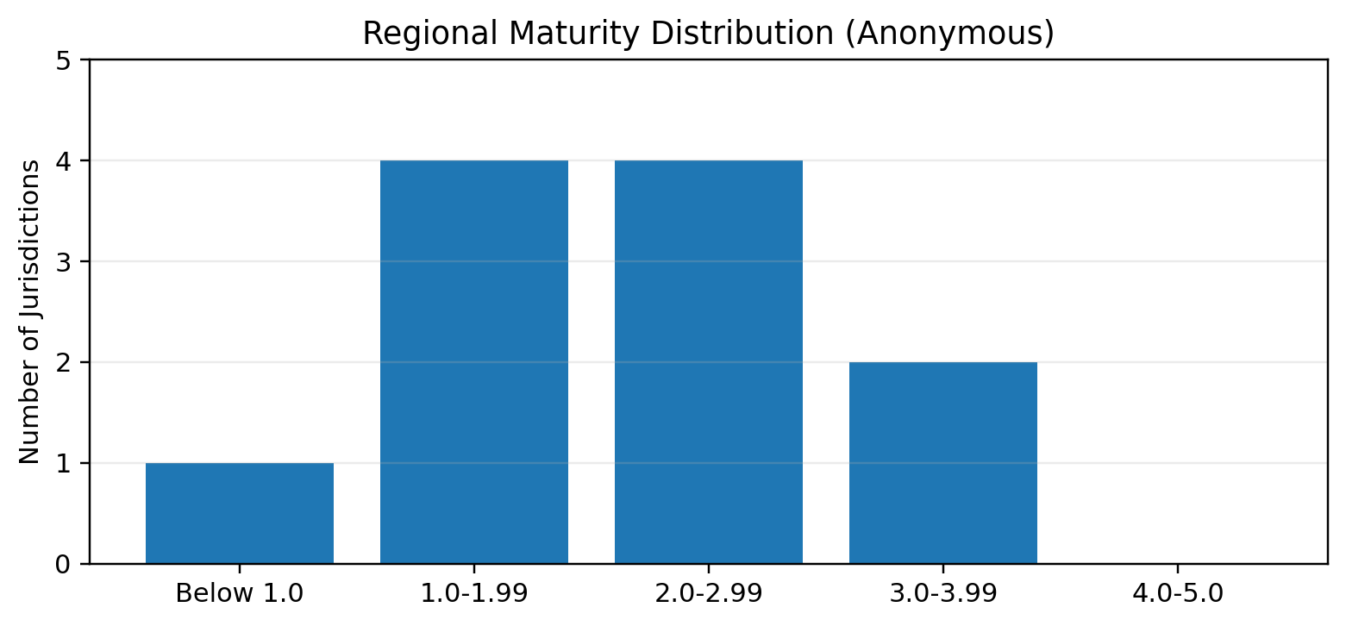
The distribution demonstrates substantial variation in maturity across the region. Five of the 11 participating jurisdictions scored below 2.0, while six scored 2.0 or higher. Two jurisdictions reached the 3.0-3.99 range, indicating more consistently implemented and evidenced capabilities, while no jurisdiction reached the 4.0 or higher range associated with broadly measured, managed, and optimized controls.
The wide range of results reinforces the value of a maturity-based approach. Participating organizations are at different starting points and therefore require different improvement strategies. Some need to establish foundational ownership, processes, and documentation, while others are positioned to focus on consistent implementation, measurement, assurance, automation, and optimization.

Maturity by Domain
The jurisdiction assessments also allow regional maturity to be viewed by the 10 assessment domains. Domain-level data is drawn from the Domain Maturity Averages reported for the ten jurisdictions that continued into tailored 90-Day Action Planning. Each regional figure is the average of the participating jurisdictions' domain averages, so every jurisdiction carries equal weight.
Domain | Jurisdictions Reporting | Regional Average | Lowest Jurisdiction | Highest Jurisdiction
Incident Response (RESPOND) | 10 | 2.62 | 1.00 | 4.31
Monitoring and Detection (DETECT) | 10 | 2.49 | 0.75 | 4.31
Governance (GOV) | 10 | 2.49 | 1.31 | 3.77
Risk Management (RISK) | 10 | 2.34 | 0.91 | 4.09
Identity and Access Management (IAM) | 10 | 2.29 | 1.00 | 3.67
Protective Safeguards (PROTECT) | 10 | 2.28 | 0.83 | 3.95
AI Lifecycle Management (AILC) | 10 | 2.22 | 0.18 | 3.80
Asset and Data Management (ASSET) | 10 | 2.15 | 0.54 | 3.77
Continuous Improvement (IMPROVE) | 10 | 2.12 | 0.92 | 3.83
Recovery and Resilience (RECOVER) | 10 | 1.90 | 0.91 | 4.40
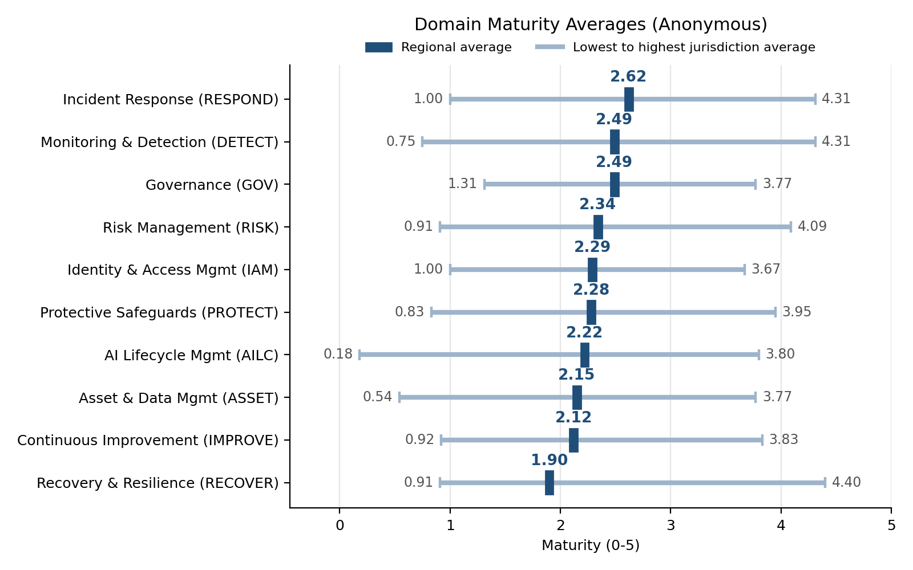
Regional domain averages fall within a relatively narrow band, from 1.90 to 2.62. Nine of the 10 domains average within the same Defined maturity range as the overall regional result, and one falls just below it. Incident Response (2.62) is the strongest domain regionally, followed by Monitoring and Detection and Governance (both 2.49), reflecting established cybersecurity operations and governance capabilities. Recovery and Resilience (1.90) is the lowest domain and the only one averaging below 2.0, followed by Continuous Improvement (2.12), Asset and Data Management (2.15), and AI Lifecycle Management (2.22).
The variation between jurisdictions within each domain is considerably greater than the variation between domains. Every domain includes at least one jurisdiction averaging near or below 1.3 and at least one averaging above 3.6. AI Lifecycle Management shows the lowest single jurisdiction result (0.18), while Recovery and Resilience shows both the lowest regional average and the highest single jurisdiction result (4.40). This pattern indicates that the regional need is less about one weak subject area and more about helping jurisdictions at earlier maturity stages establish the foundations that more mature jurisdictions already have in place.

Maturity by Control Type
Controls are grouped into four functional control types that also serve as the project's Lines of Effort (LOE). Control-type data is drawn from the LOE Maturity Band Selection tables in the ten tailored 90-Day Action Plans and is averaged in the same way as the domain data. Directive controls correspond to the Governance and Risk Management domains; Preventive controls to AI Lifecycle Management, Asset and Data Management, Identity and Access Management, and Protective Safeguards; Detective controls to Monitoring and Detection; and Corrective / Responsive controls to Incident Response, Recovery and Resilience, and Continuous Improvement.
Control Type / Line of Effort | Jurisdictions Reporting | Regional Average | Lowest Jurisdiction | Highest Jurisdiction
LOE 3 - Detective Controls | 10 | 2.49 | 0.75 | 4.31
LOE 1 - Directive Controls | 10 | 2.42 | 1.25 | 3.92
LOE 2 - Preventive Controls | 10 | 2.21 | 0.82 | 3.81
LOE 4 - Corrective / Responsive Controls | 10 | 2.19 | 0.97 | 4.17
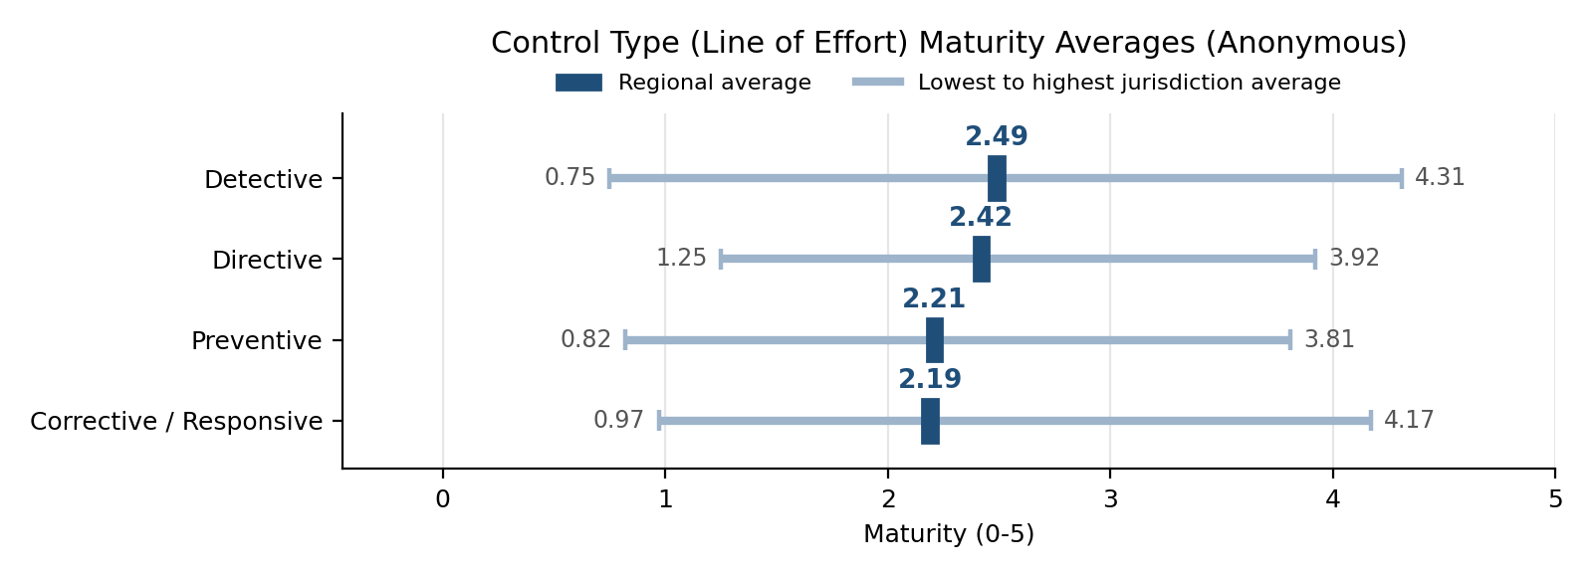
Detective controls are the most mature control type regionally (2.49), followed by Directive controls (2.42). Preventive (2.21) and Corrective / Responsive (2.19) controls are the least mature. Regionally, jurisdictions are generally better at seeing and recording activity than at consistently preventing issues or closing the loop through recovery, corrective action, and measured improvement. This aligns with the domain results, where Recovery and Resilience and Continuous Improvement, both composed of Corrective / Responsive controls, are the two lowest-scoring domains.
Each action plan matched every in-scope Line of Effort to one of five maturity transition bands, which determined the taskers selected for the 90-day cycle. Across the ten plans, 39 LOE band selections were made.
Band | 90-Day Focus | Directive | Preventive | Detective | Corrective / Responsive | Total
N/A |  | 1 | 0 | 0 | 0 | 1
0 to 1 | Establish baseline ownership | 1 | 2 | 2 | 2 | 7
1 to 2 | Formalize and document | 2 | 3 | 1 | 3 | 9
2 to 3 | Implement consistently | 5 | 3 | 5 | 4 | 17
3 to 4 | Measure and manage | 1 | 2 | 1 | 0 | 4
4 to 5 | Optimize and sustain | 0 | 0 | 1 | 1 | 2
Total |  | 10 | 10 | 10 | 10 | 40
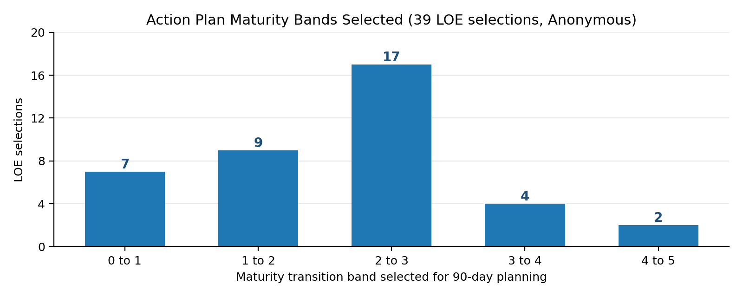
Nearly half of all selections (17 of 39) fell in the 2 to 3 band, where the focus is implementing documented practices consistently. A further 16 selections fell in the 0 to 1 and 1 to 2 bands, where the work is establishing baseline ownership and formalizing and documenting practices. Only six selections were in the 3 to 4 or 4 to 5 bands associated with measurement, management, and optimization. For most jurisdictions, the next 90-day cycle is therefore about ownership, documentation, and consistent implementation rather than optimization.

Regional Findings
A consistent theme across the Planning Workstream was that traditional cybersecurity capabilities were generally more mature than AI-specific governance and operational practices. The primary regional challenge was not a complete absence of cybersecurity capability, but uneven maturity and inconsistent implementation across organizations. The domain and control-type results support this: AI Lifecycle Management and Asset and Data Management are among the lowest-scoring domains, and Preventive and Corrective / Responsive controls trail Detective and Directive controls.
Common areas for continued improvement included AI system and use-case inventories, ownership and accountability, AI risk classification, lifecycle governance, identity and access discipline, AI-specific safeguards, monitoring and misuse detection, AI incident handling, recovery procedures, corrective-action tracking, and measurable continuous improvement.
The RAICF therefore emphasizes a visibility-first approach. Jurisdictions should understand what AI services are in use, who is responsible for them, what data they handle, what systems they can access, how they are monitored, and how they can be disabled, rolled back, or replaced when necessary.

Assessment-to-Action Process
The workstream established a repeatable improvement cycle: Self-Assessment -> Review Gaps -> Select Strategies -> Build a 90-Day Action Plan -> Reassess.
Assessment results were used to identify priority areas and select improvement actions appropriate to each jurisdiction's maturity level. The 90-Day Action Plan Framework organizes work into the same four Lines of Effort used by the assessment and provides taskers matched to five maturity transitions: 0->1, 1->2, 2->3, 3->4, and 4->5.
The 90-day period is intended as a planning cadence rather than a mandatory compliance deadline. Jurisdictions can adjust sequencing and timelines based on staffing, funding, operational priorities, governance processes, and technical complexity. At the end of the cycle, affected controls can be reassessed and the process repeated.

Planning Workstream Deliverables
The Planning Workstream produced an integrated set of regional and jurisdiction-specific products.
Core regional and foundational deliverables included:
- Regional Artificial Intelligence Cybersecurity Framework (RAICF)
- AI Cybersecurity and AI Governance Assessment Manual
- AI Cybersecurity and AI Governance Assessment Workbook
- 90-Day Action Plan Framework
- Project execution and coordination tracking products
For the ten jurisdictions that elected to continue into the improvement-planning phase, the Planning Workstream also produced tailored:
- 90-Day AI Cybersecurity and AI Governance Action Plans
- Lines of Effort briefing slides
- 90-Day implementation checklists
The remaining jurisdiction that returned a completed assessment did not continue into the tailored 90-Day Action Plan phase. Its assessment results remain included in the aggregated regional maturity data.

Overall Outcome
The Planning Workstream established more than a one-time assessment. It created a repeatable regional cybersecurity and AI governance maturity-improvement process that participating jurisdictions can continue using after the project period.
The region now has a common approach for establishing a baseline, identifying gaps, selecting improvement priorities, documenting actions, and measuring progress over time. Across the 11 completed assessments, overall maturity averaged 2.21 / 5, with scores ranging from 0.93 to 3.98. Presented in aggregate, these results establish a regional baseline while protecting the individual assessment posture of participating jurisdictions.
The results indicate that meaningful cybersecurity capability already exists across the region, but maturity varies considerably and AI-specific governance, lifecycle management, monitoring, response, and recovery remain important areas for continued development. By domain, Incident Response (2.62) is strongest and Recovery and Resilience (1.90) is lowest. By control type, Detective controls lead (2.49) while Preventive (2.21) and Corrective / Responsive (2.19) controls offer the greatest opportunity for improvement.
The resulting framework gives jurisdictions a practical path for incremental improvement while preserving local authority and existing programs. It provides a consistent regional vocabulary, common assessment methodology, and repeatable improvement process without creating a new regulatory structure or requiring jurisdictions to replace the cybersecurity and governance processes they already use.

